AI-Driven Regression Testing: Strategies for Minimizing Manual Effort

Table of Content

AI-Driven Regression Testing: Strategies for Minimizing Manual Effort 1

Introduction to Regression Testing Challenges 1

Manual vs. Automated Regression Testing 1

AI Approaches to Streamline Regression 1

AI Tools and Frameworks for Regression Testing 2

Workflow Integration and Monitoring 2

Real-World Case Studies 3

Key Benefits and Pitfalls 3

Best Practices for Adoption 4

The Role of AI in Performance Regression Testing 4

Future Outlook 5

Conclusion 5

# AI-Driven Regression Testing: Strategies for Minimizing Manual Effort

## **Introduction to Regression Testing Challenges**

Regression testing is a critical part of software development that ensures new code changes do not negatively impact existing functionality. However, traditional regression testing can be resource-intensive, time-consuming, and prone to human errors. With the increasing complexity of applications, the need for efficient regression testing methods has grown. AI-driven regression testing presents an innovative solution to these challenges, helping organizations minimize manual effort while improving accuracy and speed.

# Manual vs. Automated Regression Testing

Manual regression testing involves human testers executing predefined test cases to verify that software modifications do not introduce defects. While this approach provides flexibility and detailed exploratory testing, it is time-consuming and error-prone.

Automated regression testing, on the other hand, uses scripts and tools to run test cases automatically. Automation reduces execution time and ensures consistent results. However, maintaining automated test scripts can be challenging, especially in dynamic environments. AI-driven regression testing enhances automation by incorporating intelligent decision-making, reducing the need for constant script maintenance.

# AI Approaches to Streamline Regression

AI-driven regression testing employs machine learning algorithms and advanced analytics to optimize test selection, execution, and maintenance. Some key AI approaches include:

* **Test Case Prioritization:** AI identifies high-impact test cases based on historical test data and code changes.
* **Self-Healing Test Automation:** AI-based tools adapt to UI and code changes, reducing maintenance efforts.
* **Predictive Test Selection:** AI predicts which test cases are most relevant for a given code change, minimizing redundant testing.
* **Anomaly Detection:** AI analyzes past test results to identify unexpected failures and patterns.

These approaches significantly reduce the manual effort required to manage and execute regression tests.

# AI Tools and Frameworks for Regression Testing

Several AI-powered tools and frameworks have emerged to facilitate regression testing. Some of the most widely used include:

* **Test.ai:** Uses AI-driven automation to create and maintain test cases with minimal human intervention.
* **Applitools:** AI-powered visual testing that detects UI changes effectively.
* **Mabl:** A self-healing testing tool that adapts to changes in the application automatically.
* **Functionize:** Uses machine learning to create and maintain automated test scripts dynamically.

Organizations can leverage these tools to streamline their regression testing processes, reduce manual effort, and improve overall efficiency. Each tool brings unique capabilities, such as visual testing, self-healing automation, and predictive analytics, making them highly effective in addressing different aspects of AI-driven regression testing. Choosing the right tool depends on the organization's specific requirements, such as application complexity, existing infrastructure, and testing team expertise.

# Workflow Integration and Monitoring

For AI-driven regression testing to be effective, it must be seamlessly integrated into the software development lifecycle (SDLC). Key integration strategies include:

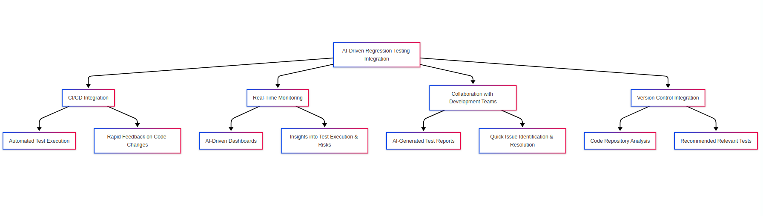**Fig 1.1 AI Regression Testing Integration workflow**

* **Continuous Integration/Continuous Deployment (CI/CD):** AI-driven tests can be triggered automatically as part of CI/CD pipelines, ensuring rapid feedback on code changes.
* **Real-Time Monitoring:** AI-driven dashboards provide insights into test execution, coverage, and potential risks.
* **Collaboration with Development Teams:** AI-generated test reports help developers quickly understand issues and take corrective actions.
* **Version Control Integration:** AI tools analyze code repositories to track changes and recommend relevant tests.

# Real-World Case Studies

Several organizations have successfully implemented AI-driven regression testing to enhance efficiency and accuracy. Examples include:

* **Case Study 1: E-commerce Platform**
  + Challenge: Frequent UI updates leading to high test maintenance.
  + Solution: AI-driven self-healing automation reduced test script maintenance by 60%.
  + Outcome: Faster releases with fewer regression issues.
* **Case Study 2: Financial Services Firm**
  + Challenge: Large codebase with complex dependencies.
  + Solution: AI-based test selection reduced regression test execution time by 50%.
  + Outcome: Improved test coverage with reduced effort.

# Key Benefits and Pitfalls

**Benefits:**

* **Reduced Manual Effort:** AI automates repetitive testing tasks, freeing up testers for higher-value activities.
* **Faster Test Execution:** Intelligent test selection and parallel execution significantly speed up regression testing.
* **Improved Accuracy:** AI eliminates human errors and increases test reliability.
* **Lower Maintenance Costs:** Self-healing automation reduces script maintenance effort.

**Pitfalls:**

* **Initial Setup Complexity:** AI-driven testing requires upfront investment in tools and training.
* **Data Dependency:** AI models rely on quality historical data for accurate predictions.
* **Limited Human Oversight:** Over-reliance on AI may lead to undetected issues that require human intervention.

# Best Practices for Adoption

To successfully implement AI-driven regression testing, organizations should consider the following best practices:

* **Start Small:** Begin with AI-powered test case selection before expanding to self-healing automation.
* **Ensure Quality Data:** Train AI models with accurate and diverse test data.
* **Integrate with DevOps:** AI-driven testing should be an integral part of CI/CD workflows.
* **Monitor AI Performance:** Regularly evaluate AI-driven test recommendations to ensure reliability.
* **Encourage Collaboration:** Foster communication between testers, developers, and AI-driven testing tools.

# The Role of AI in Performance Regression Testing

Performance regression testing ensures that new code changes do not negatively impact application performance, such as speed, scalability, and responsiveness. AI enhances performance regression testing by:

* **Predictive Performance Analysis:** AI forecasts potential performance bottlenecks before they impact users.
* **Automated Load Testing:** AI-driven tools simulate user traffic and analyze performance trends.
* **Self-Optimizing Test Scenarios:** AI dynamically adjusts test cases based on past performance data.
* **Real-Time Anomaly Detection:** AI continuously monitors application performance and flags deviations automatically.

AI-driven performance regression testing not only identifies performance issues but also provides insights into the root causes. This enables proactive optimization, helping development teams address potential performance risks before they become critical. Moreover, AI can enhance load testing by dynamically adjusting testing parameters based on real-world user behavior, improving the accuracy of performance evaluations. As applications scale, AI-driven performance regression testing ensures that they remain responsive and reliable under varying workloads.

# Future Outlook

The future of AI-driven regression testing looks promising, with advancements in machine learning and automation enhancing efficiency. Emerging trends include:

* **AI-Powered Autonomous Testing:** AI-driven tools will evolve to create, execute, and adapt test cases without human intervention.
* **Integration with DevSecOps:** AI will enhance security testing within regression frameworks.
* **Adaptive Learning Models:** AI algorithms will continuously improve based on real-world test data.
* **Voice and NLP-Based Test Automation:** AI will enable natural language processing (NLP) for test script generation and execution.

# Conclusion

AI-driven regression testing offers a powerful solution to minimize manual effort while improving test accuracy and efficiency. By leveraging AI for test selection, execution, and maintenance, organizations can accelerate software delivery without compromising quality. While challenges exist, adopting best practices and integrating AI within CI/CD workflows can maximize the benefits of AI-driven regression testing. As AI technology evolves, its role in software testing will only continue to expand, driving greater innovation and efficiency in the testing landscape.